Задание №1

Условие:

Необходимо создать приложение, содержащее все практические работы по Windows Forms.

Исходный код программы:

AdvancedGraphForm.cs:

using System;

using System.Collections.Generic;

using System.ComponentModel;

using System.Data;

using System.Drawing;

using System.Drawing.Drawing2D;

using System.Drawing.Imaging;

using System.Linq;

using System.Text;

using System.Threading.Tasks;

using System.Windows.Forms;

namespace AllFormsExample

{

public partial class AdvancedGraphForm : Form

{

bool drawing; GraphicsPath currentPath; Point oldLocation; Pen currentPen;

public AdvancedGraphForm(Color meow, FormStartPosition startscreen)

{

InitializeComponent();

drawing = false;

currentPen = new Pen(Color.Black);

StartPosition = startscreen;

BackColor = meow;

}

private void Form1_Load(object sender, EventArgs e)

{

}

private void picDrawingSurface_MouseDown(object sender, MouseEventArgs e)

{

if (picDrawingSurface.Image == null)

{

MessageBox.Show("Сначала создайте новый файл!");

return;

}

if (e.Button == MouseButtons.Left)

{

drawing = true;

oldLocation = e.Location;

currentPath = new GraphicsPath();

}

}

private void picDrawingSurface_MouseUp(object sender, MouseEventArgs e)

{

drawing = false;

try

{

currentPath.Dispose();

}

catch

{

};

}

private void picDrawingSurface_MouseMove(object sender, MouseEventArgs e)

{

if (drawing)

{

Graphics g = Graphics.FromImage(picDrawingSurface.Image);

currentPath.AddLine(oldLocation, e.Location);

g.DrawPath(currentPen, currentPath);

oldLocation = e.Location; g.Dispose();

picDrawingSurface.Invalidate();

}

}

private void новыйToolStripMenuItem_Click(object sender, EventArgs e)

{

if (picDrawingSurface.Image != null)

{

var result = MessageBox.Show("Сохранить текущее изображение перед созданием нового рисунка?", "Предупреждение", MessageBoxButtons.YesNoCancel);

switch (result)

{

case DialogResult.No:

break;

case DialogResult.Yes:

сохранитьToolStripMenuItem_Click(sender, e);

break;

case DialogResult.Cancel:

return;

}

}

Bitmap pic = new Bitmap(614, 300);

picDrawingSurface.Image = pic;

Graphics grf = Graphics.FromImage(pic);

grf.Clear(Color.White);

picDrawingSurface.Image = pic;

}

private void сохранитьToolStripMenuItem_Click(object sender, EventArgs e)

{

SaveFileDialog SaveDlg = new SaveFileDialog();

SaveDlg.Filter = "JPEG Image|*.jpg|Bitmap Image|*.bmp|GIF Image|*.gif|PNG Image|*.png";

SaveDlg.Title = "Save an Image File";

SaveDlg.FilterIndex = 4;

SaveDlg.ShowDialog();

if (SaveDlg.FileName != "")

{

System.IO.FileStream fs = (System.IO.FileStream)SaveDlg.OpenFile();

switch (SaveDlg.FilterIndex)

{

case 1:

this.picDrawingSurface.Image.Save(fs, ImageFormat.Jpeg);

break;

case 2:

this.picDrawingSurface.Image.Save(fs, ImageFormat.Bmp);

break;

case 3:

this.picDrawingSurface.Image.Save(fs, ImageFormat.Gif);

break;

case 4:

this.picDrawingSurface.Image.Save(fs, ImageFormat.Png);

break;

}

fs.Close();

}

}

private void открытьToolStripMenuItem_Click(object sender, EventArgs e)

{

OpenFileDialog OP = new OpenFileDialog();

OP.Filter = "JPEG Image|*.jpg|Bitmap Image|*.bmp|GIF Image|*.gif|PNG Image|*.png";

OP.Title = "Open an Image File";

OP.FilterIndex = 1;

if (OP.ShowDialog() != DialogResult.Cancel)

picDrawingSurface.Load(OP.FileName);

picDrawingSurface.AutoSize = true;

}

private void выходToolStripMenuItem_Click(object sender, EventArgs e)

{

Close();

}

private void toolStripButton1_Click(object sender, EventArgs e)

{

новыйToolStripMenuItem_Click(sender, e);

}

private void toolStripButton2_Click(object sender, EventArgs e)

{

сохранитьToolStripMenuItem_Click(sender, e);

}

private void toolStripButton3_Click(object sender, EventArgs e)

{

открытьToolStripMenuItem_Click(sender, e);

}

private void toolStripButton5_Click(object sender, EventArgs e)

{

Close();

}

private void toolStripButton4_Click(object sender, EventArgs e)

{

}

private void оПрограммеToolStripMenuItem_Click(object sender, EventArgs e)

{

}

private void цветToolStripMenuItem_Click(object sender, EventArgs e)

{

}

private void пунктирToolStripMenuItem_Click(object sender, EventArgs e)

{

}

private void твердыйToolStripMenuItem_Click(object sender, EventArgs e)

{

}

private void точечныйToolStripMenuItem_Click(object sender, EventArgs e)

{

}

private void карандашToolStripMenuItem_Click(object sender, EventArgs e)

{

}

private void шагНазадToolStripMenuItem_Click(object sender, EventArgs e)

{

}

private void шагВпередToolStripMenuItem_Click(object sender, EventArgs e)

{

}

}

}

DatabaseForm.cs:

using System;

using System.Collections.Generic;

using System.ComponentModel;

using System.Data;

using System.Drawing;

using System.Linq;

using System.Text;

using System.Threading.Tasks;

using System.Windows.Forms;

namespace AllFormsExample

{

public partial class DatabaseForm : Form

{

public DatabaseForm(Color meow, FormStartPosition startscreen)

{

StartPosition = startscreen;

BackColor = meow;

InitializeComponent();

}

private void DatabaseForm_Load(object sender, EventArgs e)

{

this.группаTableAdapter.Fill(this.databaseDataSet.Группа);

// TODO: данная строка кода позволяет загрузить данные в таблицу "databaseDataSet.Студенты". При необходимости она может быть перемещена или удалена.

this.студентыTableAdapter.Fill(this.databaseDataSet.Студенты);

// TODO: данная строка кода позволяет загрузить данные в таблицу "databaseDataSet.Факультет". При необходимости она может быть перемещена или удалена.

this.факультетTableAdapter.Fill(this.databaseDataSet.Факультет);

}

private void button1_Click(object sender, EventArgs e)

{

Close();

}

}

}

Form1.cs:

using System;

using System.Drawing;

using System.Windows.Forms;

namespace AllFormsExample

{

public partial class Form1 : Form

{

public Form1()

{

InitializeComponent();

}

private void Form1_Load(object sender, EventArgs e)

{

MainTextLabel.Text = "Изучение основ языка программирования Visual С#\nКомплекс практических работ по ТРПО\nCтудента группы 4ПКС-115 Деменчука Г.М.";

}

private void button1_Click(object sender, EventArgs e)

{

SimpleGraphForm obj1 = new SimpleGraphForm(BackColor, StartPosition);

obj1.Show();

}

private void button2_Click(object sender, EventArgs e)

{

DatabaseForm obj2 = new DatabaseForm(BackColor, StartPosition);

obj2.Show();

}

private void button3_Click(object sender, EventArgs e)

{

AdvancedGraphForm obj3 = new AdvancedGraphForm(BackColor, StartPosition);

obj3.Show();

}

private void button4_Click(object sender, EventArgs e)

{

UntraditionalForms obj4 = new UntraditionalForms(BackColor, StartPosition);

obj4.Show();

}

private void синийToolStripMenuItem_Click(object sender, EventArgs e)

{

this.BackColor = Color.Blue;

}

private void сбросToolStripMenuItem_Click(object sender, EventArgs e)

{

this.BackColor = SystemColors.Control;

}

private void красныйToolStripMenuItem_Click(object sender, EventArgs e)

{

this.BackColor = Color.Red;

}

private void зеленыйToolStripMenuItem_Click(object sender, EventArgs e)

{

this.BackColor = Color.Green;

}

private void белыйToolStripMenuItem_Click(object sender, EventArgs e)

{

this.BackColor = Color.White;

}

private void button5_Click(object sender, EventArgs e)

{

ProgressBarForm obj5 = new ProgressBarForm(BackColor, StartPosition);

obj5.Show();

}

private void button6_Click(object sender, EventArgs e)

{

ListExampleForm obj6 = new ListExampleForm(BackColor, StartPosition);

obj6.Show();

}

private void button7_Click(object sender, EventArgs e)

{

PaintForm obj7 = new PaintForm(BackColor, StartPosition);

obj7.Show();

}

private void button8_Click(object sender, EventArgs e)

{

GraphForm obj8 = new GraphForm(BackColor, StartPosition);

obj8.Show();

}

private void поУмолчанияToolStripMenuItem_Click(object sender, EventArgs e)

{

this.StartPosition = FormStartPosition.WindowsDefaultLocation;

}

private void центрToolStripMenuItem_Click(object sender, EventArgs e)

{

this.StartPosition = FormStartPosition.CenterScreen;

}

private void аАToolStripMenuItem_Click(object sender, EventArgs e)

{

this.Size = new Size(1000, 1000);

}

private void розовыйToolStripMenuItem_Click(object sender, EventArgs e)

{

this.BackColor = Color.Pink;

}

}

}

GraphForm.cs:

using System;

using System.Drawing;

using System.Windows.Forms;

namespace AllFormsExample

{

public partial class GraphForm : Form

{

private const int Level = 5;

private int _width;

private int _height;

private Bitmap _fractal;

private Graphics _graph;

public GraphForm(Color meow, FormStartPosition startscreen)

{

InitializeComponent();

_width = FractalPictureBox.Width;

_height = FractalPictureBox.Height;

StartPosition = startscreen;

BackColor = meow;

}

private PointF MidPoint(PointF p1, PointF p2)

{

return new PointF((p1.X + p2.X) / 2f, (p1.Y + p2.Y) / 2f);

}

private void DrawCarpet(int level, RectangleF carpet)

{

if (level == 0)

_graph.FillRectangle(Brushes.OrangeRed, carpet);

else

{

var width = carpet.Width / 3f;

var height = carpet.Height / 3f;

var x1 = carpet.Left;

var x2 = x1 + width;

var x3 = x1 + 2f * width;

var y1 = carpet.Top;

var y2 = y1 + height;

var y3 = y1 + 2f * height;

DrawCarpet(level - 1, new RectangleF(x1, y1, width, height)); // левый 1(верхний)

DrawCarpet(level - 1, new RectangleF(x2, y1, width, height)); // средний 1

DrawCarpet(level - 1, new RectangleF(x3, y1, width, height)); // правый 1

DrawCarpet(level - 1, new RectangleF(x1, y2, width, height)); // левый 2

DrawCarpet(level - 1, new RectangleF(x3, y2, width, height)); // правый 2

DrawCarpet(level - 1, new RectangleF(x1, y3, width, height)); // левый 3

DrawCarpet(level - 1, new RectangleF(x2, y3, width, height)); // средний 3

DrawCarpet(level - 1, new RectangleF(x3, y3, width, height)); // правый 3

}

}

private void GraphForm_Paint(object sender, PaintEventArgs e)

{

}

private void GraphForm_Load(object sender, EventArgs e)

{

_fractal = new Bitmap(_width, _height);

_graph = Graphics.FromImage(_fractal);

RectangleF carpet = new RectangleF(0, 0, _width, _height);

DrawCarpet(Level, carpet);

FractalPictureBox.BackgroundImage = _fractal;

}

}

}

ListsExampleForm.cs:

using System;

using System.Drawing;

using System.Windows.Forms;

namespace AllFormsExample

{

public partial class ListExampleForm : Form

{

public ListExampleForm(Color meow, FormStartPosition startscreen)

{

StartPosition = startscreen;

BackColor = meow;

InitializeComponent();

}

private void button1_Click(object sender, EventArgs e)

{

textBox1.Text = ""; textBox1.Focus();

}

private void button2_Click(object sender, EventArgs e)

{

comboBox1.Items.Add(textBox1.Text);

textBox1.Text = "";

textBox1.Focus();

}

private void button3_Click(object sender, EventArgs e)

{

int i = comboBox1.SelectedIndex;

if (i != -1)

{

comboBox1.Items.Insert(i, textBox1.Text);

textBox1.Text = "";

textBox1.Focus();

}

}

private void button4_Click(object sender, EventArgs e)

{

int i = comboBox1.SelectedIndex;

if (i != -1)

comboBox1.Items.RemoveAt(i);

}

private void button5_Click(object sender, EventArgs e)

{

int i = comboBox1.SelectedIndex;

if (i != -1)

listBox1.Items.Add(comboBox1.Items[i]);

}

}

}

PaintForm.cs:

using System;

using System.Drawing;

using System.Windows.Forms;

namespace AllFormsExample

{

public partial class PaintForm : Form

{

public PaintForm(Color meow, FormStartPosition startscreen)

{

StartPosition = startscreen;

BackColor = meow;

InitializeComponent();

}

private void GraphInitializer()

{

double Xmin = Convert.ToDouble(textBoxXmin.Text);

double Xmax = Convert.ToDouble(textBoxXmax.Text);

double Step = Convert.ToDouble(textBoxStep.Text);

double b = -0.8;

int count = (int)Math.Ceiling((Xmax - Xmin) / Step) + 1;

double[] x = new double[count];

double[] y1 = new double[count];

for (int i = 0; i < count; i++)

{

x[i] = Xmin + Step * i;

y1[i] = Math.Pow(i, 2) + Math.Tan((5 * i) + (b / i));

}

chart1.ChartAreas[0].AxisX.Minimum = Xmin; chart1.ChartAreas[0].AxisX.Maximum = Xmax;

chart1.ChartAreas[0].AxisX.MajorGrid.Interval = Step;

chart1.Series[0].Points.DataBindXY(x, y1);

}

private void Form1_Load(object sender, EventArgs e)

{

}

private void buttonCalc_Click(object sender, EventArgs e)

{

try

{

GraphInitializer();

}

catch (Exception)

{

}

}

}

}

ProgressBarForm.cs:

using System;

using System.Drawing;

using System.Windows.Forms;

namespace AllFormsExample

{

public partial class ProgressBarForm : Form

{

Timer time = new Timer();

public ProgressBarForm(Color meow, FormStartPosition startscreen)

{

StartPosition = startscreen;

BackColor = meow;

InitializeComponent();

}

private void button1_Click(object sender, EventArgs e)

{

time.Interval = 250;

time.Tick += new EventHandler(IncreaseProgressBar);

time.Start();

}

private void button2_Click(object sender, EventArgs e)

{

time.Stop();

}

private void IncreaseProgressBar(object sender, EventArgs e)

{

progressBar1.Increment(1);

toolStripStatusLabel1.Text = progressBar1.Value.ToString() + "% Выполнено";

if (progressBar1.Value == progressBar1.Maximum)

{

time.Stop();

progressBar1.Value = 0;

}

}

private void button3_Click(object sender, EventArgs e)

{

progressBar1.Value = 0;

toolStripStatusLabel1.Text = "0";

}

}

}

SimpleGraphForm.cs

using System;

using System.Drawing;

using System.Drawing.Imaging;

using System.Windows.Forms;

namespace AllFormsExample

{

public partial class SimpleGraphForm : Form

{

public SimpleGraphForm(Color meow, FormStartPosition startscreen)

{

StartPosition = startscreen;

BackColor = meow;

InitializeComponent();

}

private void comboBox1_SelectedIndexChanged(object sender, EventArgs e)

{

}

private void выходToolStripMenuItem_Click(object sender, EventArgs e)

{

Close();

}

private void pictureBox1_Click(object sender, EventArgs e)

{

}

public void LoadImg(string path)

{

Image image = Image.FromFile(path);

int width = image.Width;

int height = image.Height;

pictureBox1.Image = image;

pictureBox1.Width = width;

pictureBox1.Height = height;

}

private void ВолгаToolStripMenuItem_Click(object sender, EventArgs e)

{

MainLabel.Text = "На картинке река Волга";

LoadImg("../../../jpg/volga.jpg");

}

private void МоскваToolStripMenuItem_Click(object sender, EventArgs e)

{

MainLabel.Text = "На картинке река Москва";

LoadImg("../../../jpg/moskva.jpg");

}

private void ОкаToolStripMenuItem_Click(object sender, EventArgs e)

{

MainLabel.Text = "На картинке река Ока";

LoadImg("../../../jpg/oka.jpg");

}

private void ЧерноеToolStripMenuItem_Click(object sender, EventArgs e)

{

MainLabel.Text = "На картинке Черное море";

LoadImg("../../../jpg/black.jpg");

}

private void БалтийскоеToolStripMenuItem_Click(object sender, EventArgs e)

{

MainLabel.Text = "На картинке Балтийское море";

LoadImg("../../../jpg/balta.jpg");

}

private void АзовскоеToolStripMenuItem_Click(object sender, EventArgs e)

{

MainLabel.Text = "На картинке Азовское море";

LoadImg("../../../jpg/azov.jpg");

}

private void ЛадожскоеToolStripMenuItem_Click(object sender, EventArgs e)

{

MainLabel.Text = "На картинке Ладожское озеро";

LoadImg("../../../jpg/ladoshskoye.jpg");

}

private void ОнежскоеToolStripMenuItem_Click(object sender, EventArgs e)

{

MainLabel.Text = "На картинке Онежское озеро";

LoadImg("../../../jpg/oneshskoye.jpg");

}

private void БайкалToolStripMenuItem_Click(object sender, EventArgs e)

{

MainLabel.Text = "На картинке озеро Байкал";

LoadImg("../../../jpg/baykal.jpg");

}

private void открытьИзФайлаToolStripMenuItem_Click(object sender, EventArgs e)

{

OpenFileDialog dialog = new OpenFileDialog();

dialog.Filter = "Image files (*.BMP, *.JPG, *.GIF, *.PNG)| *.bmp; *.jpg; *.gif; *.png";

if (dialog.ShowDialog() == DialogResult.OK)

{

Image image = Image.FromFile(dialog.FileName);

int width = image.Width;

int height = image.Height;

pictureBox1.Width = width;

pictureBox1.Height = height;

pictureBox1.Image = image;

MainLabel.Text = "Ваше загруженное изображение:";

}

}

private void сохранитьКакToolStripMenuItem_Click(object sender, EventArgs e)

{

try

{

pictureBox1.Image.Save("../../../output.jpg", ImageFormat.Jpeg);

}

catch (System.NullReferenceException)

{

MessageBox.Show("Не загружено изображение");

}

}

private void рисункиToolStripMenuItem_Click(object sender, EventArgs e)

{

}

}

}

UntraditionalForms.cs:

using System;

using System.Drawing;

using System.Windows.Forms;

namespace AllFormsExample

{

public partial class UntraditionalForms : Form

{

Point moveStart;

public UntraditionalForms(Color meow, FormStartPosition startscreen)

{

StartPosition = startscreen;

BackColor = meow;

InitializeComponent();

FormBorderStyle = FormBorderStyle.None;

}

private void ExitButton_Click(object sender, EventArgs e)

{

Close();

}

private void UntraditionalForms_Load(object sender, EventArgs e)

{

System.Drawing.Drawing2D.GraphicsPath myPath = new System.Drawing.Drawing2D.GraphicsPath();

myPath.AddEllipse(0, 0, this.Width, this.Height);

Region myRegion = new Region(myPath);

Region = myRegion;

}

private void UntraditionalForms_MouseDown(object sender, MouseEventArgs e)

{

if (e.Button == MouseButtons.Left)

moveStart = new Point(e.X, e.Y);

}

private void UntraditionalForms_MouseMove(object sender, MouseEventArgs e)

{

if ((e.Button & MouseButtons.Left) != 0)

{

Point deltaPos = new Point(e.X - moveStart.X, e.Y - moveStart.Y);

Location = new Point(Location.X + deltaPos.X,

Location.Y + deltaPos.Y);

}

}

}

}

Скриншоты программы: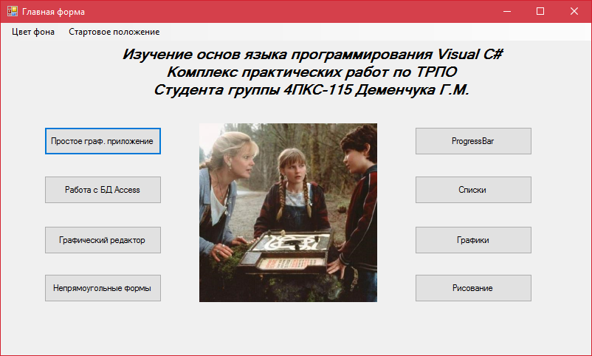

А) Главное меню программы

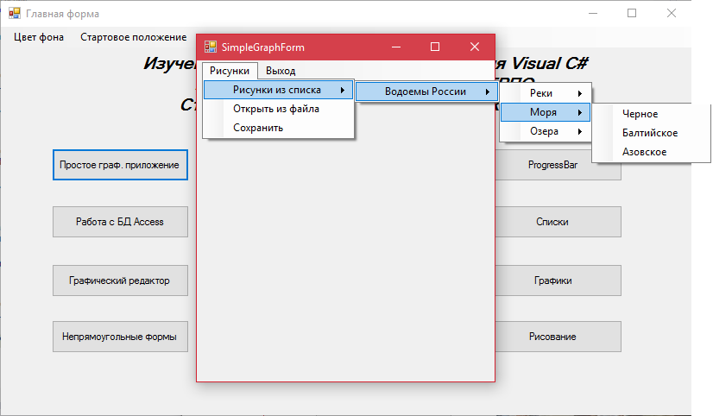

Б) Форма простого графического приложения

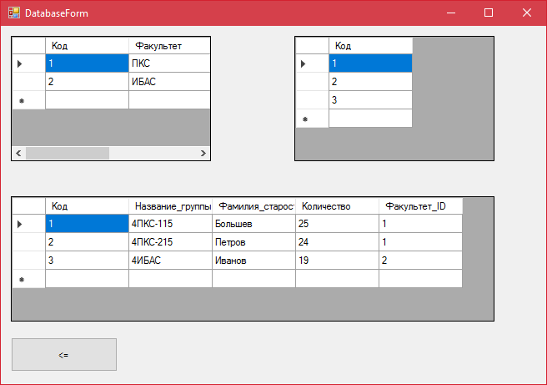

В) Форма для работы с БД Access

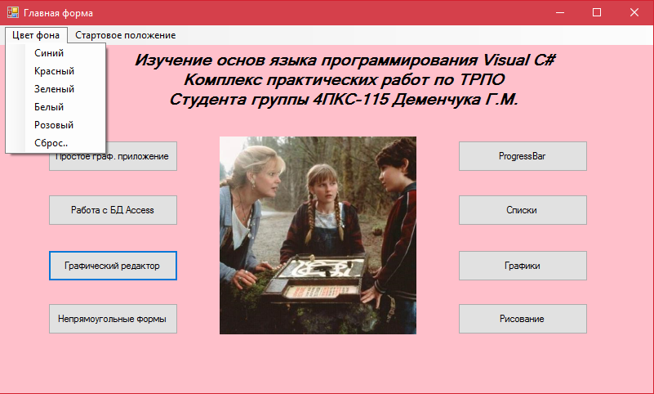

Г) Изменение цвета фона на розовый с помощью MenuStrip

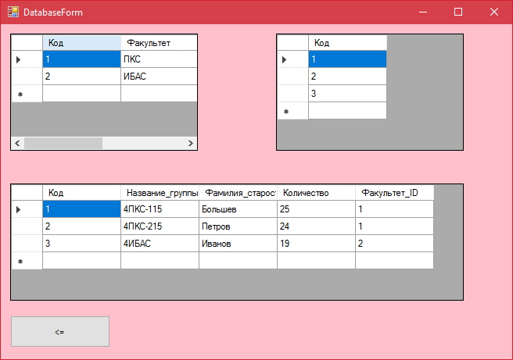

Д) Изменение цвета фона на других формах приложения с помощью передачи данных в конструктор

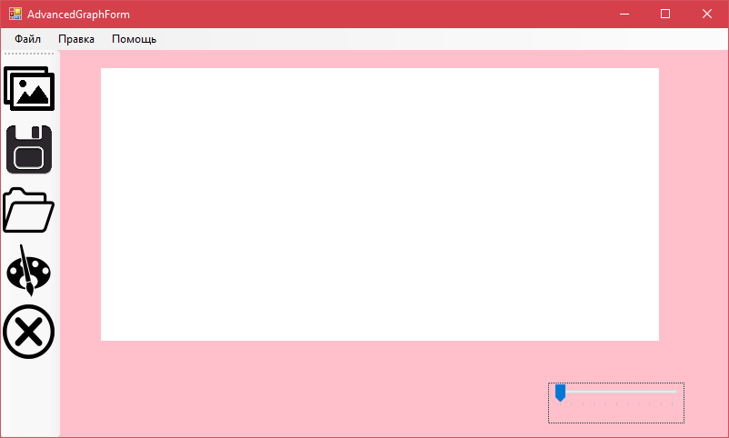

Е) Форма графического редактора

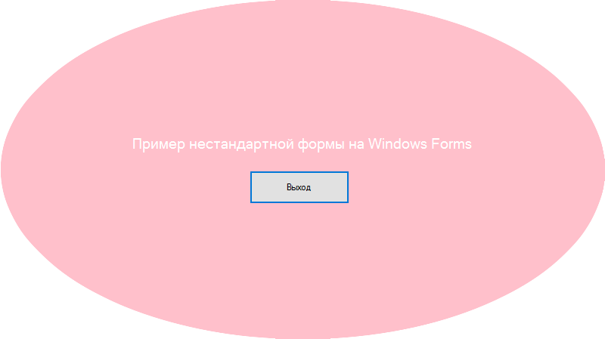

Ё) Пример нестандартной формы

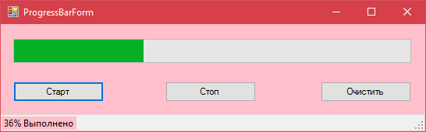

Ж) Пример Progressbar

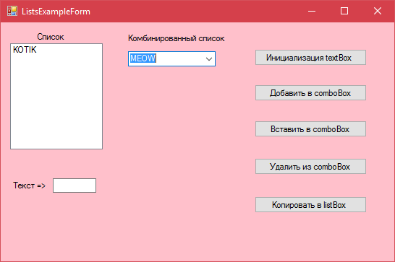

З) Пример работы со списками

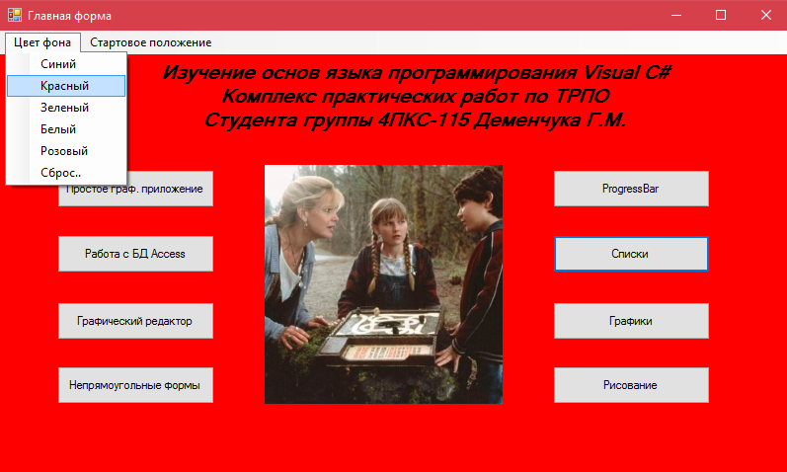

И) Изменение цвета заднего фона приложения на красный

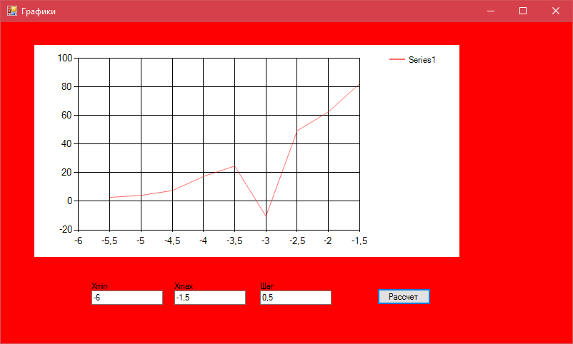

Й) Пример работы с графиками

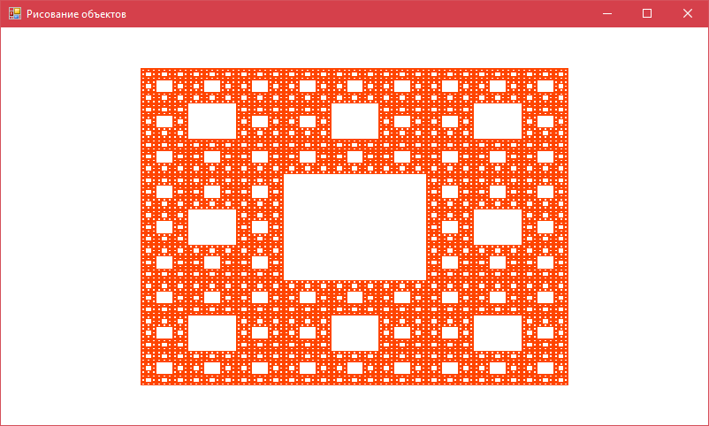 К) Пример работы с графикой